**Section 1: Creating a New Enterprise Geodatabase**

This section describes how to create a new enterprise geodatabase. ArcGIS has a tool that creates the database. When you run the tool, a database will be created on a server. The instance of the database is named “beryl”. SQL_Server is the database platform. In the “Database (optional)” field below, enter the name of the geologic map (without spaces, for example Mt Nutt should be MtNutt or Mt_Nutt) for which you are creating a database (i.e., “Cibola”).

1. 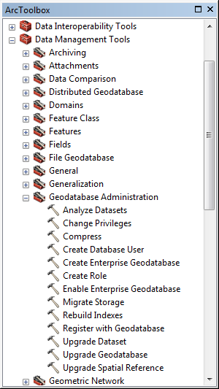Open ArcMap C:\Program Files (x86)\ArcGIS\Desktop10.2\bin\Icons\ArcMap16.png or ArcCatalog C:\Program Files (x86)\ArcGIS\Desktop10.2\bin\Icons\ArcCatalog16.png
2. Open ArcToolbox C:\Program Files (x86)\ArcGIS\Desktop10.2\bin\Icons\GeoprocessingArcToolboxWindowShow16.png
3. Run geoprocessing tool C:\Program Files (x86)\ArcGIS\Desktop10.2\bin\Icons\GeoprocessingTool16.png **Create Enterprise Geodatabase**
4. Fill out the C:\Program Files (x86)\ArcGIS\Desktop10.2\bin\Icons\GeoprocessingTool16.png Create Enterprise Geodatabase form:

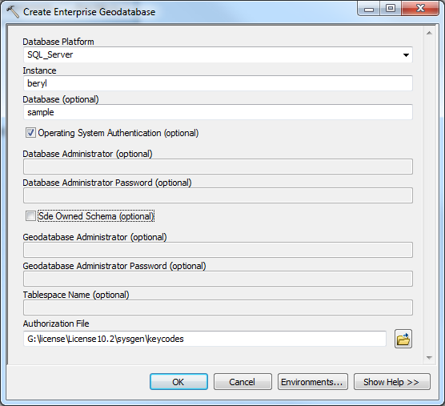

1. Click **OK** and wait.
2. Wait time is ~ 1 min 45 seconds.
3. A dialog box appears to tell you if it worked or not

**Section 2: Connect to New Enterprise Database**

1. Open ArcMap C:\Program Files (x86)\ArcGIS\Desktop10.2\bin\Icons\ArcMap16.png or ArcCatalog C:\Program Files (x86)\ArcGIS\Desktop10.2\bin\Icons\ArcCatalog16.png
2. Under Catalog Tree, expand Database Connections:

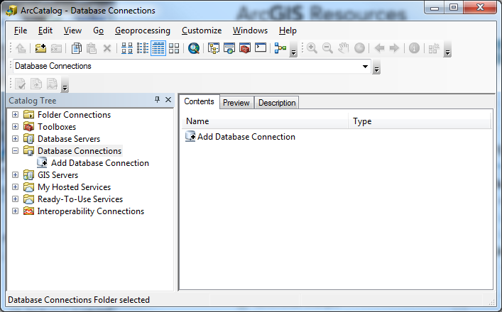

1. Double-click on **Add Database Connection**
2. Fill out Database Connection form:

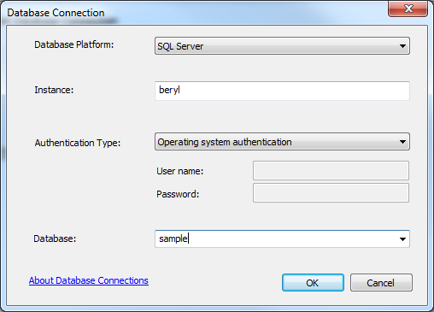

1. Click OK (no dialog box will appear to tell you if you did it correctly)
2. Rename connection in the catalog tree – i.e. rename the file “Connection to beryl.sde” to “HookerHotSpring2.sde” or something like that – probably the file name should be the same as the Enterprise Geodatabase created in the previous section (the .sde file is a “connection file” that includes the path and name of the database – this .sde file will allow you to access that database).

**Section 3: Making the New Enterprise Geodatabase a Geologic Map Database (an alternative procedure is on the next page).**

This section describes how to make your new enterprise database a geologic map database.

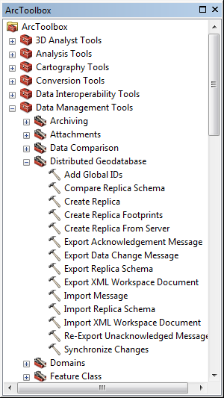

1. Open ArcMap C:\Program Files (x86)\ArcGIS\Desktop10.2\bin\Icons\ArcMap16.png or ArcCatalog C:\Program Files (x86)\ArcGIS\Desktop10.2\bin\Icons\ArcCatalog16.png
2. Open ArcToolbox C:\Program Files (x86)\ArcGIS\Desktop10.2\bin\Icons\GeoprocessingArcToolboxWindowShow16.png
3. Run C:\Program Files (x86)\ArcGIS\Desktop10.2\bin\Icons\GeoprocessingTool16.png Import XML Workspace Document
4. Fill out the C:\Program Files (x86)\ArcGIS\Desktop10.2\bin\Icons\GeoprocessingTool16.png Import XML Workspace Document form.

“Target Geodatabase” is sde file created in previous step.

(in ArcCatalog, drag .sde connection file into “Target

Geodatabase” box):

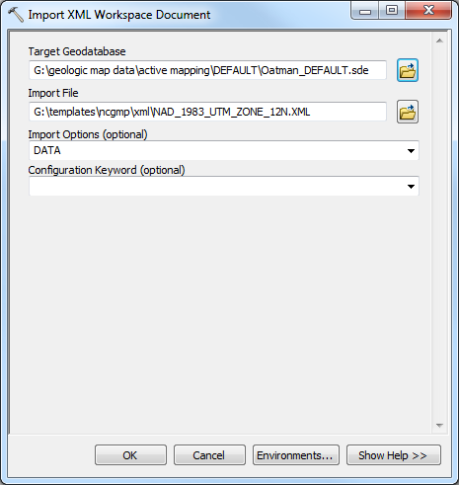

1. Click **OK** and wait.
2. Wait time is ~ 1 min 17 sec.

**Section 3 Alternate: Making the New Enterprise Geodatabase a Geologic Map Database**

1. Open ArcMap C:\Program Files (x86)\ArcGIS\Desktop10.2\bin\Icons\ArcMap16.png or ArcCatalog C:\Program Files (x86)\ArcGIS\Desktop10.2\bin\Icons\ArcCatalog16.png
2. Right-click on database, select:
   1. Import ->XML Workspace Document…

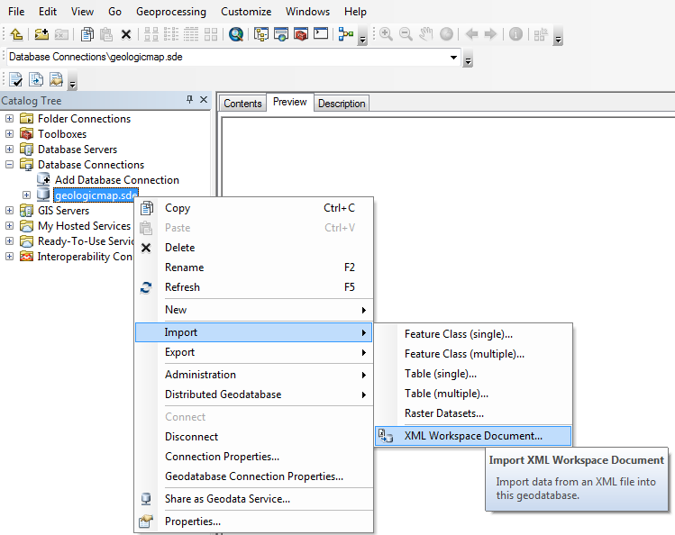

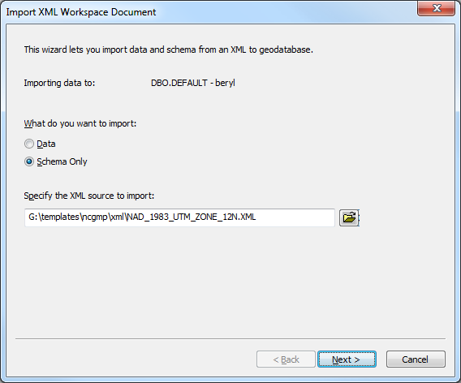

* 1. Select the xml document that has the appropriate spatial reference for the area you are working in.
  2. Click Next. A new window opens. Click Finish or whatever the button is to complete this step.

**Section 4: Versioning Database**

1. 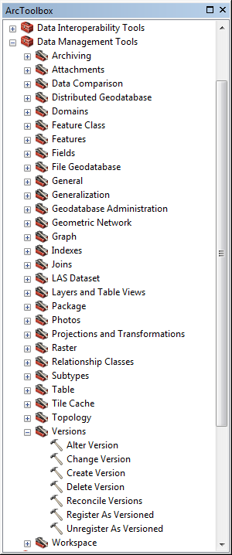Open ArcMap C:\Program Files (x86)\ArcGIS\Desktop10.2\bin\Icons\ArcMap16.png or ArcCatalog C:\Program Files (x86)\ArcGIS\Desktop10.2\bin\Icons\ArcCatalog16.png
2. Open ArcToolbox C:\Program Files (x86)\ArcGIS\Desktop10.2\bin\Icons\GeoprocessingArcToolboxWindowShow16.png
3. Run C:\Program Files (x86)\ArcGIS\Desktop10.2\bin\Icons\GeoprocessingTool16.png **Register as Versioned** inbatch mode:
   1. Right-click on tool and select batch

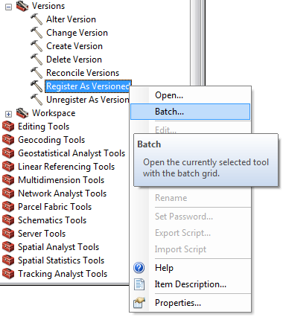

* 1. With the *exception* of the SysInfo table, drag and drop all feature datasets, feature classes and tables from database into tool window

(see window below – all feature data sets, etc.,

must be visible so they can be dragged).

* 1. Click **OK** and wait.
  2. Wait time is ~ 26 seconds.

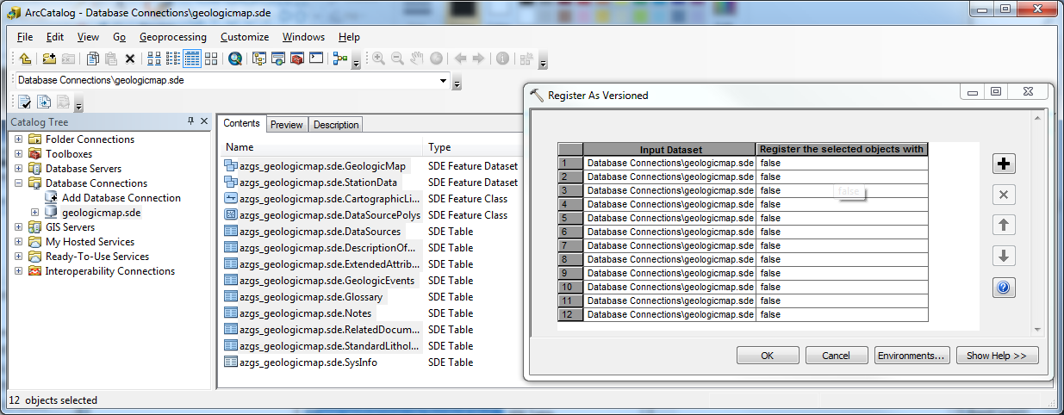

**Section 5: Creating Versions**

1. Open ArcMap C:\Program Files (x86)\ArcGIS\Desktop10.2\bin\Icons\ArcMap16.png or ArcCatalog C:\Program Files (x86)\ArcGIS\Desktop10.2\bin\Icons\ArcCatalog16.png
2. Open ArcToolbox C:\Program Files (x86)\ArcGIS\Desktop10.2\bin\Icons\GeoprocessingArcToolboxWindowShow16.png
3. Run C:\Program Files (x86)\ArcGIS\Desktop10.2\bin\Icons\GeoprocessingTool16.png **Create Version** inbatch mode:
   1. Right-click on tool and select batch

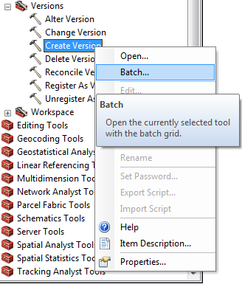

* 1. Drag .sde file (see below) into Create Version *Input Database Connection* field. To make multiple versions click on the plus sign in the Create Version box, and drag the .sde file into each input database connection box.
  2. Enter “dbo.DEFAULT” for *Parent Version (or double click in this box and select)*
  3. Input version name
  4. Select PUBLIC for *Access Permissions*
  5. Repeat for other versions (right-click in Parent Version box – see what happens)
  6. 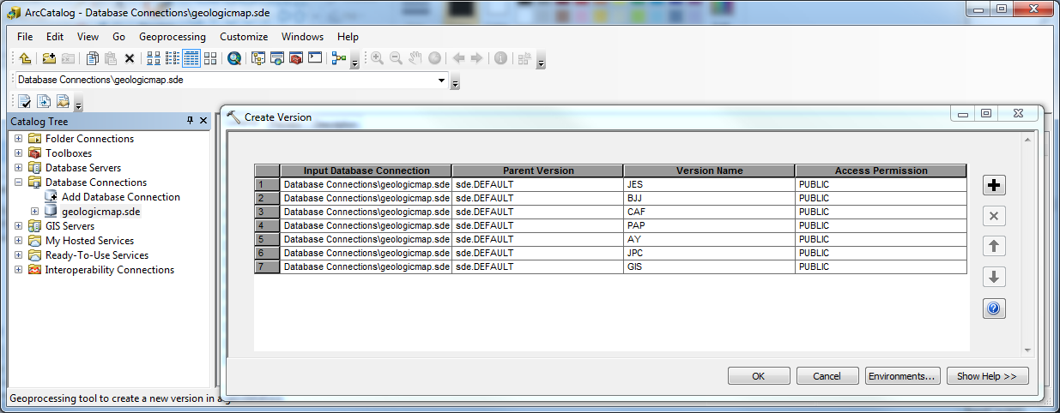Click **OK** and wait.
  7. Wait time is ~ 2 seconds. Eventually a Create Version box with a green check mark will appear.

**Section 6:**

**Read KB *Open NCGMP Database***